Agenda Presenter Action
1. Membership Forum Brian Wheeler, Chair

2. Call to Order Brian Wheeler, Chair

3. Meeting Minutes – February 16, 2017 Brian Wheeler, Chair Discuss/Motion

4. Sketch & Final Plan Review

BSOA #7206 Big Sky Community Organization Janet Storey, Staff Discuss/Motion
Installation of 2nd Yurt
Legal: Sweetgrass Hills Subdivision – Lot 2A-1
Street: 373 Little Coyote Rd.

5. Electrical Plan Review

BSOA #04608 Boneham – Renovation/Addition Janet Storey, Staff Discuss/Motion
Legal: Meadow Village Subdivision Block 6 Lot 8 & 9
Street: 2165 Spotted Elk Road

6. Discussion Items

- Parking Resolution update Suzan Scott, Staff
- Covenant Compliance Tracking Janet Storey, Staff
- Performance Deposit Tracking Janet Storey, Staff
- Adjourn Brian Wheeler, Chair

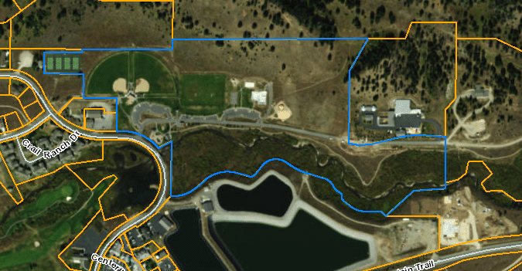

Big Sky Community Organization Community Park

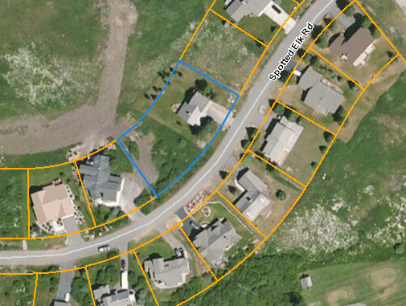

Boneham – 2165 Spotted Elk Rd.

